THE INSILICO LAB
3-Week Virtual Training in CADD
Week 3

AI-Based Structure Evaluation

Participant Name  ________Caren Nicole Moreno__________ | Date Submitted  ____________07/19/2026_______________
Cohort / Batch  ____________Cohort 5_______________ | Email Address  _______carenmoreno28@gmail.com___________

📋 Before You Begin
This is the final week of The Insilico Lab Training Programme

TASK 1 | AI-Based Structure Evaluation (AlphaFold3)

Objective: To demonstrate the ability to use AlphaFold3 to predict a protein structure and evaluate it against the experimental structure.

▸ Task Description
1 | Go to the Protein Data Bank (https://www.rcsb.org) and search for 1U72.
2 | On the 1U72 entry page, locate the FASTA sequence file. Download it (File → FASTA Sequence).
3 | Open the FASTA file in a text editor and copy the sequence.
4 | Go to AlphaFold3 (https://alphafoldserver.com) and create a new prediction job.
5 | Paste the FASTA sequence into AlphaFold3 and submit the prediction.
6 | Once complete, download the predicted structure (CIF format).
7 | Open both the predicted structure and your cleaned 1U72 (from Week 1 Task 3) in PyMOL.
8 | Use PyMOL's alignment function to align the predicted structure onto the experimental structure: type 'align predicted, experimental' in the PyMOL command line.
9 | Take screenshots of: (1) the predicted structure alone, (2) the aligned overlay of both structures.
10 | Note the RMSD value reported by PyMOL after alignment.

AlphaFold3 Processing Time
AlphaFold3 predictions may take several minutes, depending on server load. Submit your job early and check back later.

▸ Deliverable 1A — FASTA Sequence
Paste the FASTA sequence for 1U72 in the box below.

>1U72_A | Paste sequence below:
>1U72_1|Chain A|Dihydrofolate reductase|Homo sapiens (9606)
VGSLNCIVAVSQNMGIGKNGDLPWPPLRNEFRYFQRMTTTSSVEGKQNLVIMGKKTWFSIPEKNRPLKGRINLVLSRELKEPPQG
AHFLSRSLDDALKLTEQPELANKVDMVWIVGGSSVYKEAMNHPGHLKLFVTRIMQDFESDTFFPEIDLEKYKLLPEYPGVLSDVQ
EEKGIKYKFEVYEKND

▸ Deliverable 1B — Structural Files Summary

# | Deliverable | Your Response / Submission
1 | FASTA sequence file name | 1U72.fasta
2 | AlphaFold3 predicted structure file name | 1U72predicted.cif
3 | Cleaned experimental structure file name (Week 1) | 1U72prepared.pdb
4 | RMSD value after alignment (Å) | 0.420
5 | Number of residues aligned | 1240 atoms (186 residue)

▸ Deliverable 1C — AlphaFold3 Website Screenshot
Note
Take a full screenshot of the AlphaFold3 results page showing the predicted structure rendered on the website. Annotate it to highlight the confidence colour coding (pLDDT score colouring).

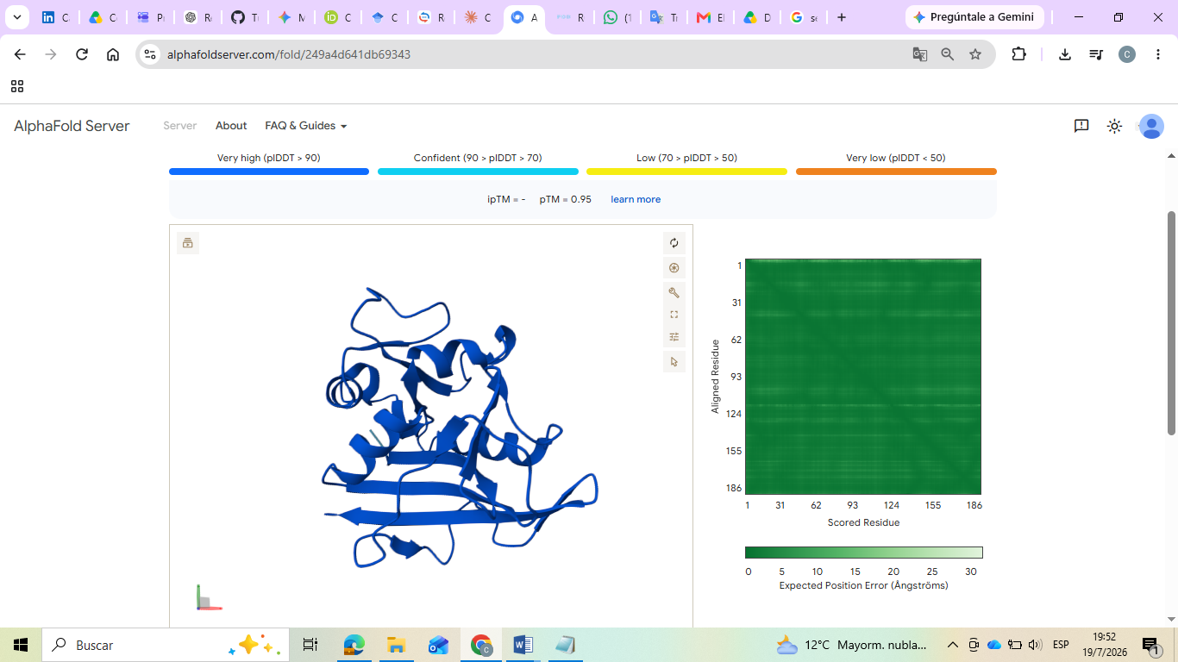
Screenshot 1 — AlphaFold3 Predicted Structure (Full Website Screenshot)

▸ Deliverable 1D — PyMOL Visualizations
Note
Produce two PyMOL images: one of the predicted structures alone, and one overlay of both structures after alignment. Use contrasting colours for the two structures in the alignment view.

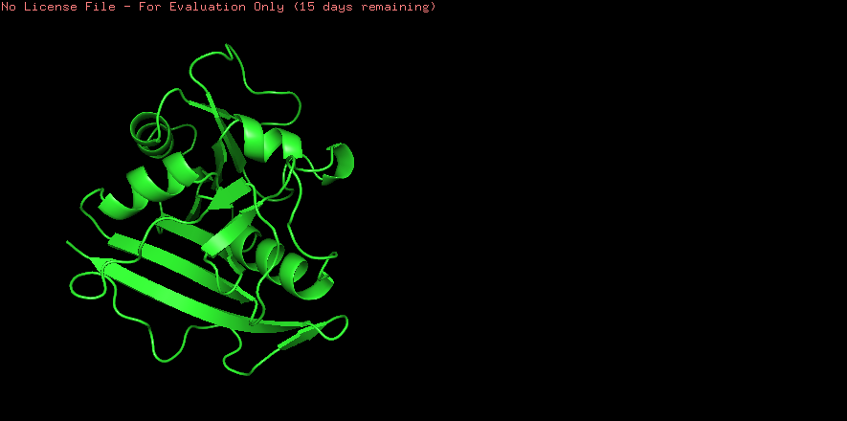
Screenshot 2 — AlphaFold3 Predicted 1U72 Structure Alone (PyMOL)

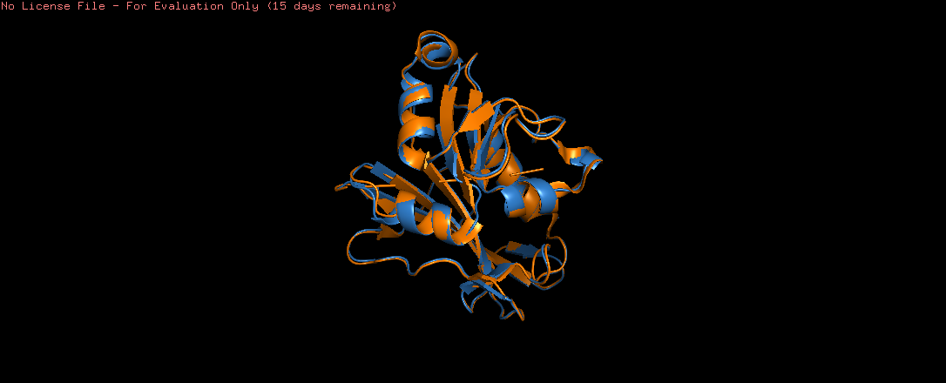
Screenshot 3 — Aligned Overlay: Predicted vs Experimental 1U72 (PyMOL)

▸ Alignment Quality Summary

Metric | Value | Interpretation
RMSD (Å) | 0.420 | < 2 Å = excellent; 2–4 Å = good; > 4 Å = poor
Residues Aligned | 1240 atoms (essentially the full 186-residue chain) | Higher = better coverage
Overall Quality | Excellent | Excellent / Good / Acceptable / Poor

▸ Written Justification
How well does the AlphaFold3 predicted structure match the experimental structure? Discuss the RMSD value, any structural differences you observed, and what this tells us about the reliability of AI-based structure prediction for this protein. (Write 4–6 sentences below)

The AlphaFold3-predicted structure aligned almost perfectly with the experimental 1U72 structure,
producing an RMSD of 0.420 Å across 1240 atoms after PyMOL's iterative refinement discarded a small
number of outlier atoms (from an initial 1502 down to 1240 over five cycles). This level of agreement
falls well within the "excellent" range and shows that AlphaFold3 reproduced both the core beta-sheet
and alpha-helical regions of the DHFR fold with near-crystallographic accuracy. The atoms rejected
during refinement likely correspond to flexible surface loops or side chains with minor conformational shifts, which is expected given that the AlphaFold3 model was generated without the bound methotrexate and NADPH present in the crystal structure. Since ligand binding can subtly reshape the active site and nearby loops, this small residual deviation is consistent with the absence of those cofactors in the prediction rather than a structural error. Overall, this result reinforces that AlphaFold3 can generate highly accurate, near-experimental models for well-characterized folds like DHFR, though experimental structures remain the gold standard for capturing ligand-induced details that a sequence-only prediction cannot access.

📣 LINKEDIN PORTFOLIO POST
Week 3 — Final Submission

Important
This is ONE single post combining both tasks. Do NOT create separate posts. This is your final Week 3 post — make it stand out!

▸ What to Include in Your Post

# | Deliverable | Your Response / Submission
1 | Annotated image of the FASTA sequence file of 1U72 (Task 1) | 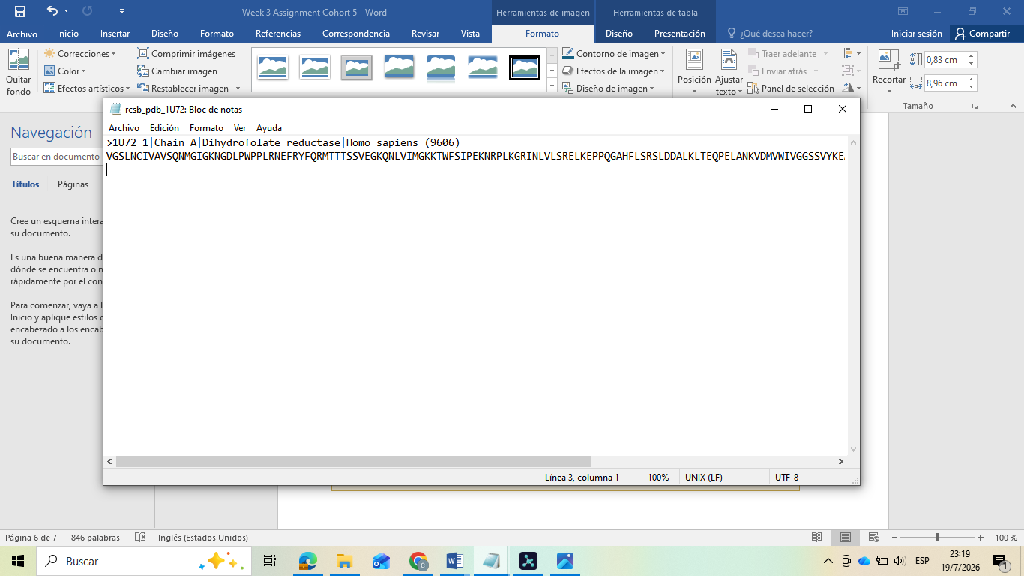
2 | Full AlphaFold3 website screenshot showing the predicted structure (Task 1) | 
3 | PyMOL image of the aligned predicted and cleaned experimental structures (Task 1) | 
4 | Brief caption for each image (what it shows and what you learned) | Image 1: This is the raw amino acid sequence of Human DHFR (1U72), retrieved from RCSB PDB. It's the only input AlphaFold3 needs to generate a full 3D structure prediction from scratch.  Image 2: AlphaFold3's predicted structure, colored by pLDDT confidence score. Most of the model falls in the high-confidence range, reflecting strong prediction reliability for this well-studied fold.  Image 3: Overlay of the AlphaFold3 prediction (blue) and the experimental crystal structure (orange) in PyMOL. An RMSD of 0.420 Å confirms an excellent structural match between AI prediction and experimental data.

▸ Tagging & Hashtags
Tag: @The Insilico Lab

#CADD | #DrugDiscovery | #ComputationalBiology | #VirtualResearch | #TheInsilicoLab | #Chemoinformatics

🎓 Congratulations!
You have completed all three weeks of The Insilico Lab Training Programme.
Protein Selection → Binding Site Analysis → Protein Preparation → Drug-likeness Screening → Molecular Docking → ADMET Prediction → AI Structure Evaluation

End of Week 3 Assignment Template
Good luck! The Insilico Lab Team

